Sennheiser Group sets to wow MPTS2024 visitors with its audio solutions
Sennheiser, Neumann and Merging Technologies will present their latest audio technologies at London's Media Production & Technology Show

Marlow, UK, 2 May 2024 – The Sennheiser Group is delighted to be returning to MPTS, the UK’s premier event for the media and entertainment industry, scheduled to take place between 15-16 May at Olympia London. Show attendees will have the opportunity to experience Sennheiser’s latest MKH 8030, a part of the MKH 8000 RF condenser microphone series, along with other solutions such as Neumann studio monitors and Merging Technologies’ Anubis, as well as the group’s latest professional headphones.

The long-awaited MKH 8030 figure-of-eight RF condenser microphone unlocks M-S, double M-S, and Blumlein stereo recording options for the recording professional. The sound signature of the MKH 8030 has been carefully engineered to blend in harmoniously with the sound of the other MKH 8000 series microphones. The MKH 8030 is also a great choice wherever the highest attenuation of neighbouring sound sources is required – be it a PA system whose sound needs to be eliminated or an adjacent instrument that must not be picked up. Their special RF condenser principle and the symmetrical capsule design endows the MKH 8000 series microphones with a combination of advantages that can only be found in this series: Remarkable sensitivity paired with durability in adverse climatic conditions, wide frequency response, low self-noise, and a natural, coherent sound image with no off-axis coloration.

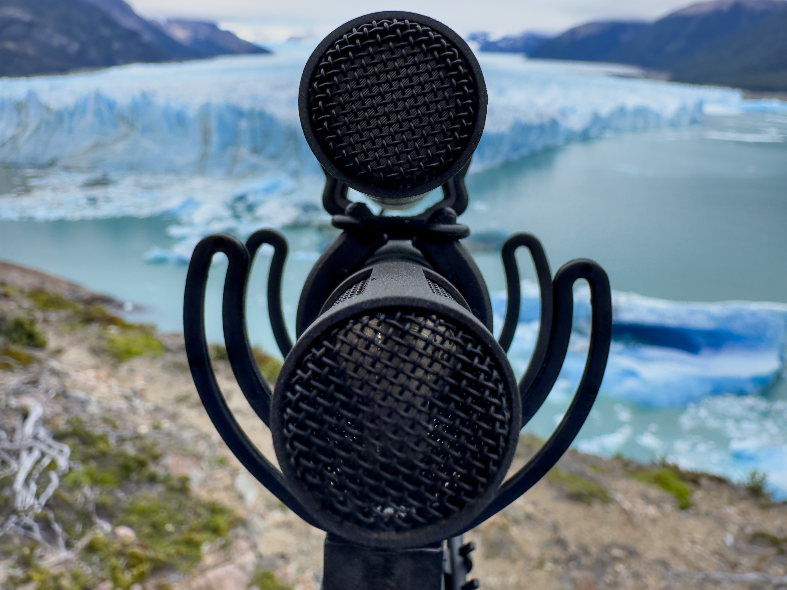
The Sennheiser MKH 8000 series is at home in the most diverse recording situations, from the orchestra pit to field recording in extreme climates (photo credit for the fjord shot: Thomas Rex Beverly)

Neumann’s reference-class audio interface MT 48 will be shown with both the Music Mission for content creation and the brand-new Monitor Mission. The latter turns the device into a freely configurable monitor controller and audio-interface for stereo, surround and immersive formats. The MT 48 will also be used for demoing Neumann’s KH-line of studio monitors as well as the NDH 20 closed-back and NDH 30 open-back headphones.

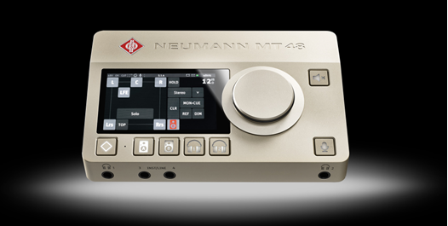

Merging Technologies will showcase its innovative range of audio technology and AoIP solutions. Visitors can talk with experts about how to utilise this technology in their specific workflows.

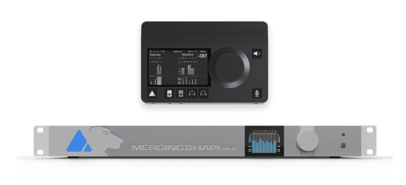
Additionally, the 5th generation of Sennheiser’s popular wireless microphone systems for camera use, EW-DP, will be on show. Purpose-built for content creators, filmmakers, and broadcasters, EW-DP is a fully digital UHF wireless microphone system with a new portable design and unmatched audio quality. At its heart is a compact, intelligent receiver that helps even novice users set up their audio with ease. The EW-DP EK receiver features an innovative magnetic stacking system, and can be conveniently controlled remotely via the Smart Assist app.

Sennheiser’s team, including Lee Shuttlewood, Tim Constable, Adrian Reid, and Emerging Technology’s Paul Mortimer will be on hand to provide product information and present latest solutions during the show.

“As we’re prepping for this year’s MPTS, the show offers a perfect platform to not only bring our latest solutions for professional users within media and broadcast industries, but also be part of important discussions affecting our industry,” concludes Lee Shuttlewood, Business Development Manager at Sennheiser. “We’re excited to bring our roster of Sennheiser, Neumann, and Merging Technologies solutions to the show and let visitors experience them first hand.”

Visit Sennheiser on Stand G73 at The Media Production & Technology Show at Olympia London from 15-16 May 2024.

(Ends)

About the Sennheiser Group

Building the future of audio and creating unique sound experiences for our customers - this is the aspiration that unites the employees of the Sennheiser Group worldwide. The independent family-owned company Sennheiser was founded in 1945. Today, it is managed in the third generation by Dr. Andreas Sennheiser and Daniel Sennheiser, and is one of the leading manufacturers in the field of professional audio technology.
sennheiser.com | neumann.com | dear-reality.com | merging.com

